Project Title: Humidity and Temperature Sensor
Link: https://wiki.microduino.cc/index.php/Temperature_%26_Humidity_Sensor

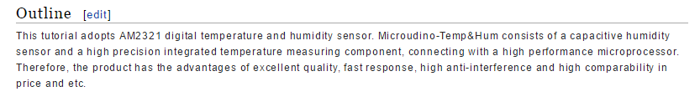
ORIGINAL:
This tutorial adopts AM2321 digital temperature and humidity sensor. Microudino-Temp&Hum consists of a capacitive humidity sensor and a high precision integrated temperature measuring component, connecting with a high performance microprocessor. Therefore, the product has the advantages of excellent quality, fast response, high anti-interference and high comparability in price and etc.
EDIT:
This mCookie sensor uses an AM2321 chip and the standard mCookie connector to give you the ability to quickly add high precision temperature measuring and humidity sensing to any Microduino project. The sensor has an on-board microprocessor delivering rapid response, high noise tolerance and excellent data quality.

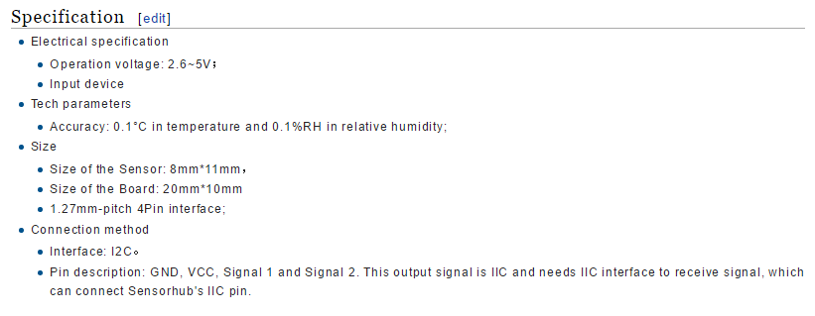

ORIGINAL:
- Electrical specification
  - Operation voltage: 2.6~5V；
  - Input device
- Tech parameters
  - Accuracy: 0.1°C in temperature and 0.1%RH in relative humidity;
- Size
  - Size of the Sensor: 8mm*11mm，
  - Size of the Board: 20mm*10mm
  - 1.27mm-pitch 4Pin interface;
- Connection method
  - Interface: I2C。
  - Pin description: GND, VCC, Signal 1 and Signal 2. This output signal is IIC and needs IIC interface to receive signal, which can connect Sensorhub's IIC pin

EDIT:
- Electrical Specifications
  - Operating Voltage: 2.6~5V
  - Output: Outputs data over an I2C bus
- Technical Specifications
  - Resolution:
    - 0.1 Degrees Celsius (°C)
    - 0.1 percent (%) Relative Humidity
- Dimensions
  - Dimensions of the Sensor: 8mm*11mm
  - Dimensions of the Board: 20mm*10mm
  - Connector Interface: 4Pin 1.27mm-pitch
- Communication Protocol
  - Interface: I²C
  - Pins: SDA (data), SCL (clock), VCC (power) and GND (ground)

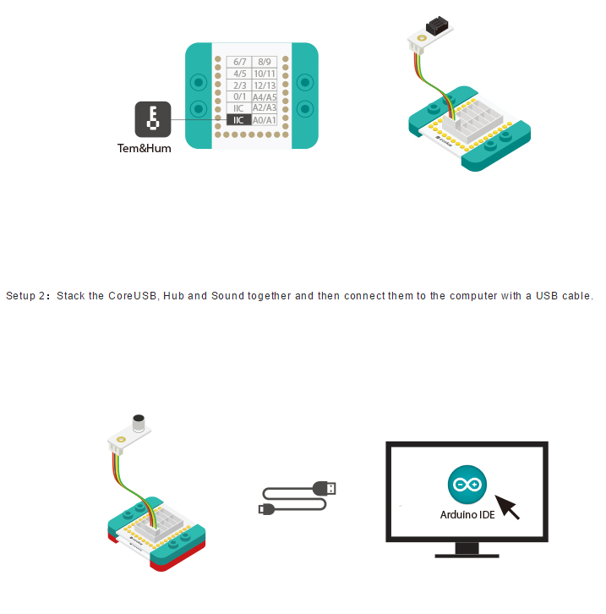

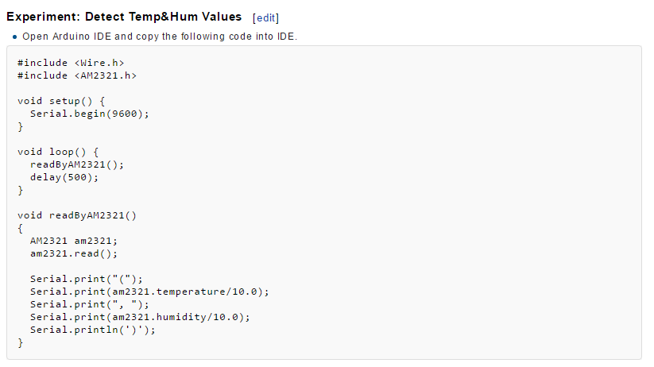

ORIGINAL:
- Open Arduino IDE and copy the following code into IDE.
EDIT:
- Open the Arduino IDE and copy the following code into the IDE, or select from the IDE examples:
File->Examples->_07_Sensor_Temp_Hum_AM2321->'read_simple'

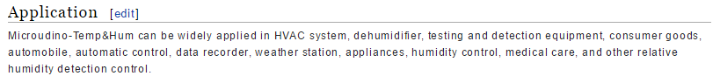
ORIGINAL:
- Microudino-Temp&Hum can be widely applied in HVAC system, dehumidifier, testing and detection equipment, consumer goods, automobile, automatic control, data recorder, weather station, appliances, humidity control, medical care, and other relative humidity detection control.
EDIT:
- The Microduino Temperature and Humidity sensor can be used in a range of applications including HVAC systems, dehumidifiers, home automation, data recording or in a weather station.

